# A brief summary of my activities, contributions and artifacts I have produced during the past week

As I mentioned in my previous week blog, we divided in a sub team so, I’m responsible for **Maintenance** and **Prevention** part for our Connected Home project. In our last project meeting we (me and Clayton) discussed on our first step towards our modules. i.e. “Maintenance” and “Prevention”. We decided to implement a reminder app into our project. Furthermore, we also discussed how to create a reminder and what’s the basic functions of it. And we did some research and survey to cover functionalities of a reminder on user perspective. Below is a list of items/activities that we will going to be listed as options to receive reminders on. I’ve researched and surveyed the timeframes that each of the activities need to be set to.

1. Test Smoke Alarm = Once per month
2. Smoke Alarm Change batteries = Twice per year
3. Test CO Detector = Once per month
4. CO Detector Change Batteries = Twice per year
5. Check Fire Extinguisher Annually = by a fire protection equipment company
6. Check Sump Pump Once per month individually, and once annually by professionals
7. Clean/Inspect Washing Machine - Twice per year
8. Clean/Inspect Dryer -Twice per year
9. Clean Dryer Vent - Twice per year
10. Test Home for Radon - Before and after any home remodelling, otherwise every 2 years - only by professionals
11. Pool Pump Filter Maintenance - When the pressure rises above 10 psi
12. Maintain Underground Sprinkler System - Once per season
13. Generator Maintenance - Monthly
14. Change HVAC Filter - Every 3 months
15. Drain Water Heater - Twice per year
16. Inspect Water Heater - Once per year - by professionals

So, in this week, I implemented a reminder application. It has covered several features.

1. Home Screen

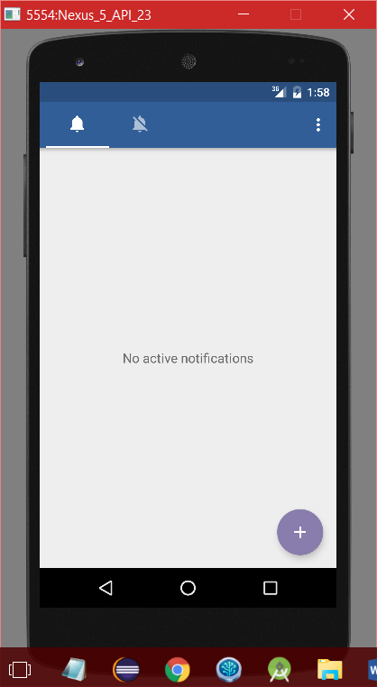

1. Create a new Reminder Screen

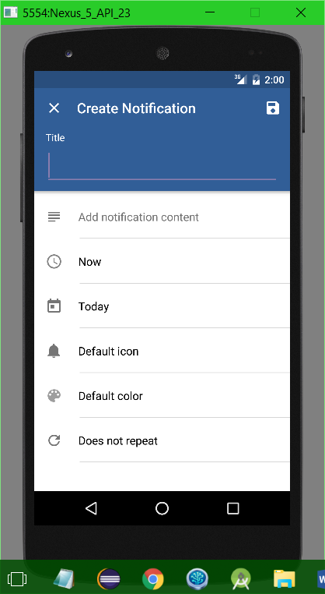

1. To select time HH:MM:SS

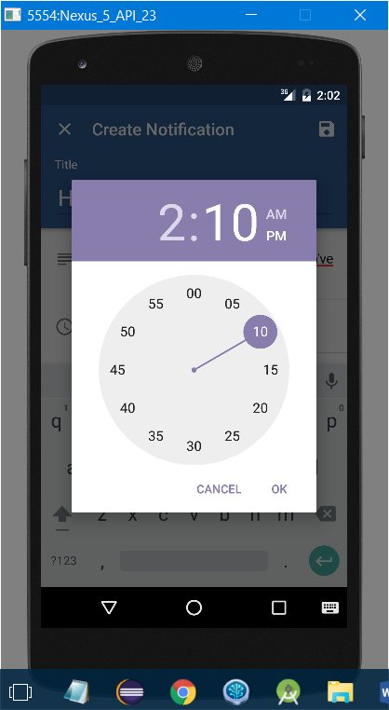

1. Calender View to choosing day

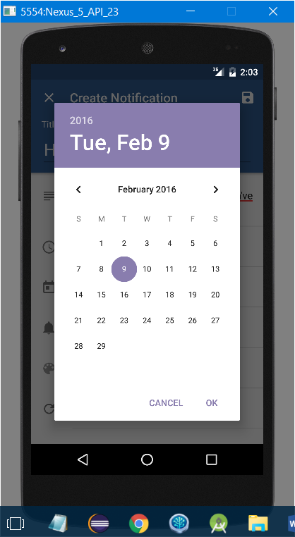

1. To choose icon for reminder

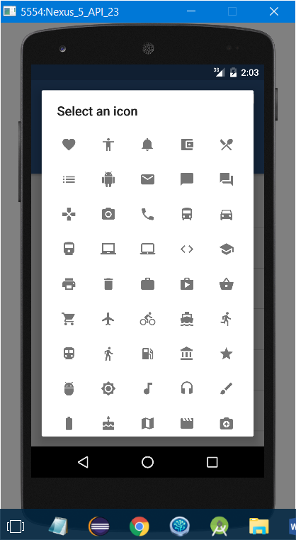

1. To choose color for reminder icon

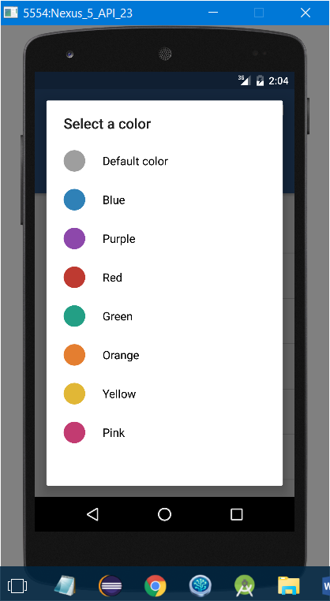

1. To choose reminder time

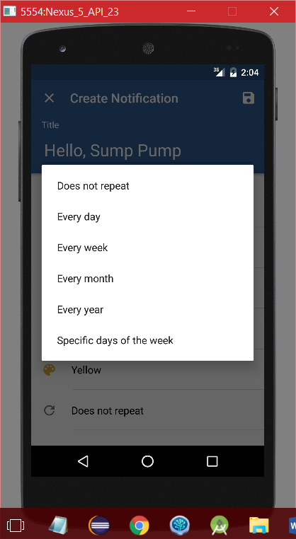

1. The whole screen with user input

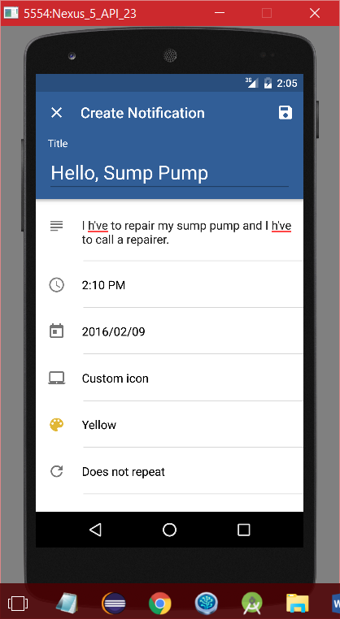

1. After creating a successful reminder

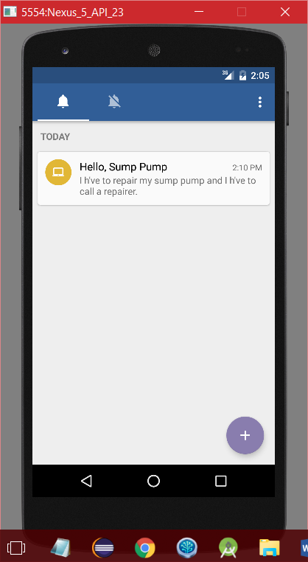

1. Screen with reminder icon on top bar.

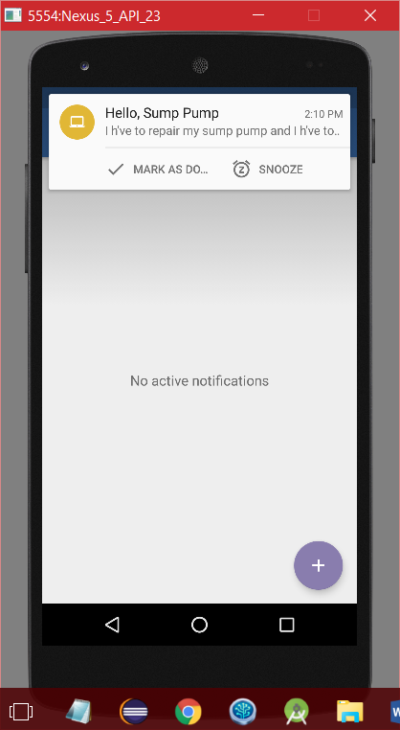

1. Reminder notification

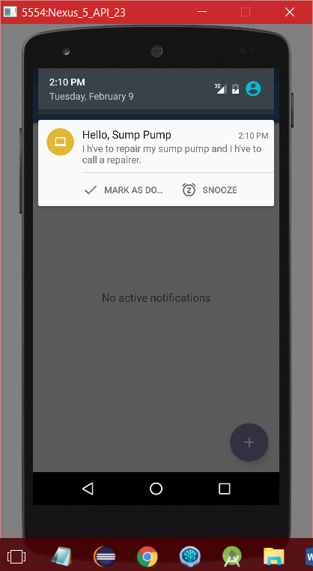

1. After clicking on reminder card

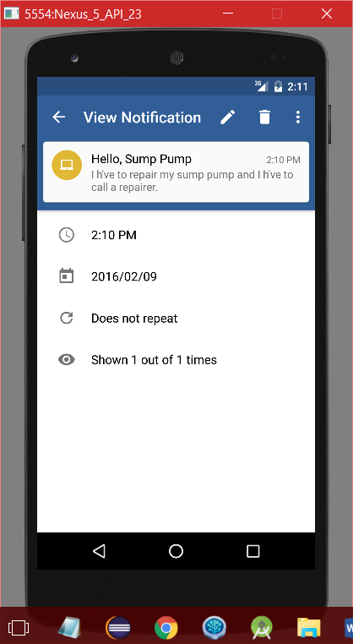

1. After clicking on edit option user can edit that reminder

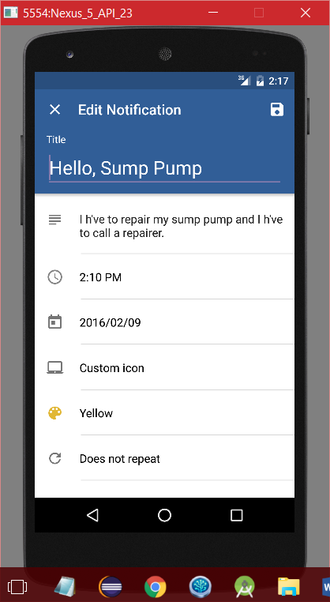

1. After clicking on Delete Button

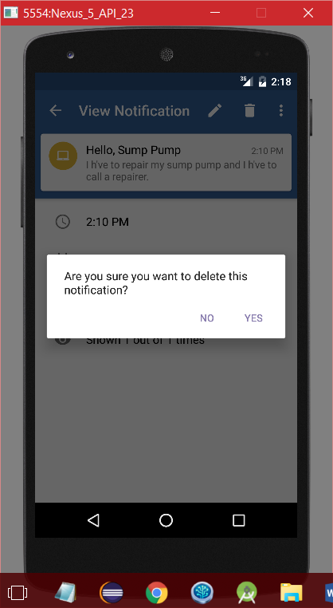

1. This is menu bar

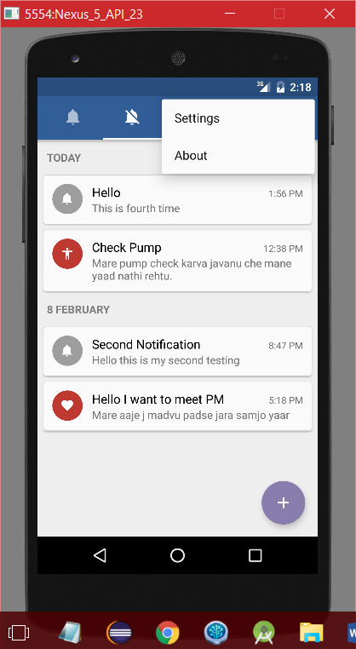

1. After clicking on Setting button

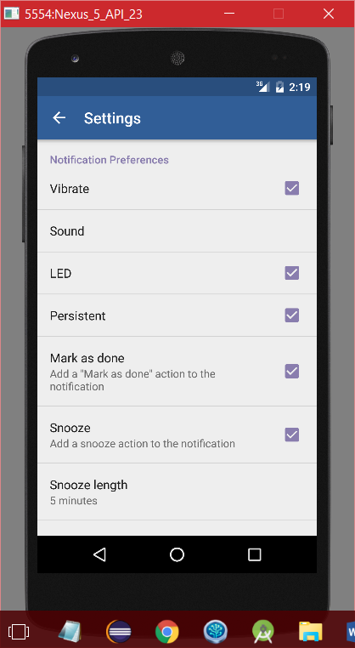

# My plans, thoughts and reflections on the state of the project for the next week

I think, I’m done with most of the R&D tasks. Next week, we are planning to add some more detailed functionalities in to this reminder app. And hopefully we want to finish as soon as possible but in the next week I have my midterms. But I will try my level best to complete our task.